

**AGBiZ Technologies**

Delivering Automated Growth in Businesses

with Technologies

*ASSIGNMENT*

**Template of Project** :

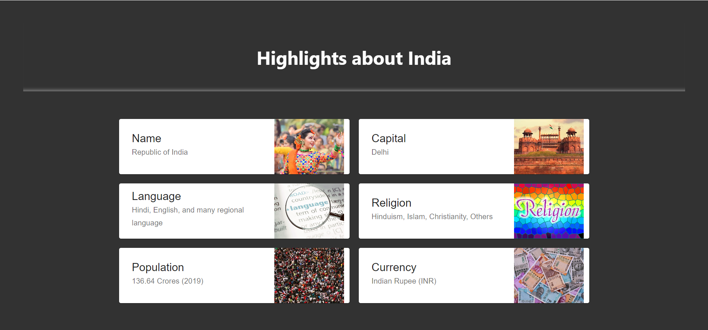

Images

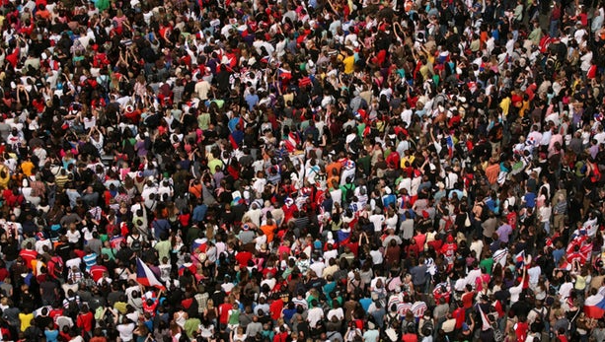

*Important*

Color Code:

background-color: rgb(50, 50, 50);

box-shadow: 0 -10px 7px -7px grey inset;

2.

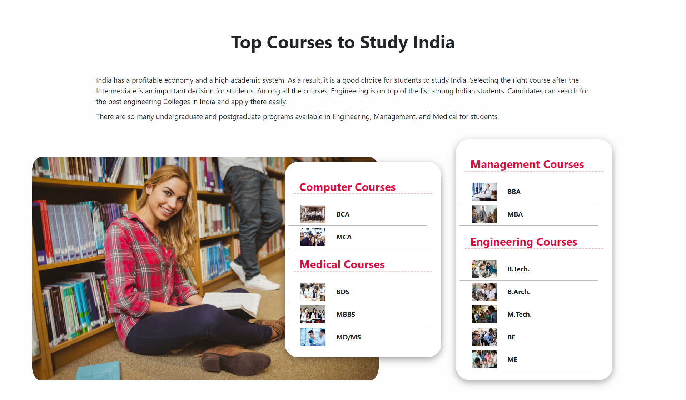

Images

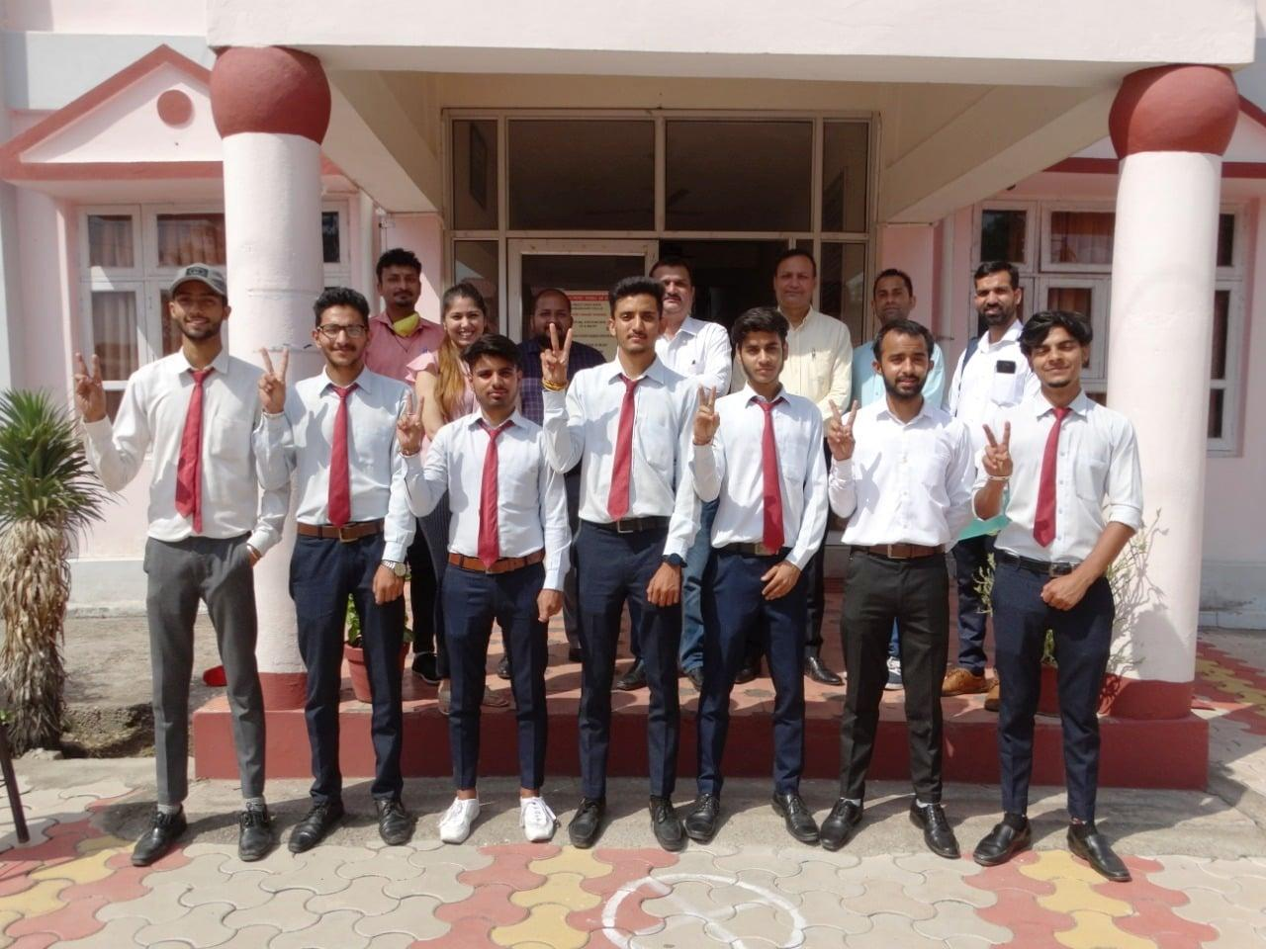



*Important*

Color Code:

background-color: rgba(182, 215, 235, 0.039);

color: rgb(233, 6, 67);

box-shadow: rgba(0, 0, 0, 0.35) 0px 5px 15px;

3. 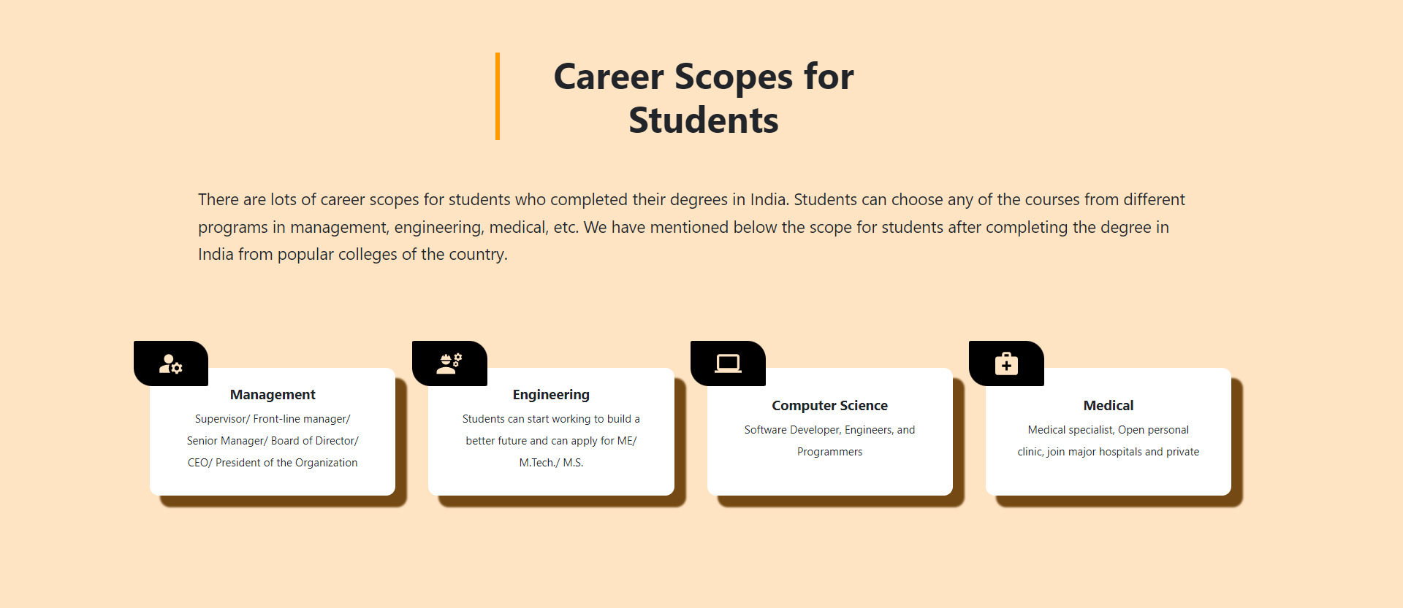

*Important*

Icons Package:

MUI Package:

1. npm install @mui/material @emotion/react @emotion/styled
2. npm install @mui/material @mui/styled-engine-sc styled-components
3. npm install @mui/icons-material

*Important*

Icons used on the website:

1. import ManageAccountsIcon from "@mui/icons-material/ManageAccounts";
2. import EngineeringIcon from '@mui/icons-material/Engineering';
3. import ComputerIcon from '@mui/icons-material/Computer';
4. import MedicalServicesIcon from '@mui/icons-material/MedicalServices';

*Important*

Reference website link: <https://mui.com/material-ui/material-icons/>

*Important*

Color Code:

background-color: bisque;

border-left: 5px solid rgb(255, 153, 0);

box-shadow: 12px 12px 2px 1px rgb(117, 73, 19);

4. 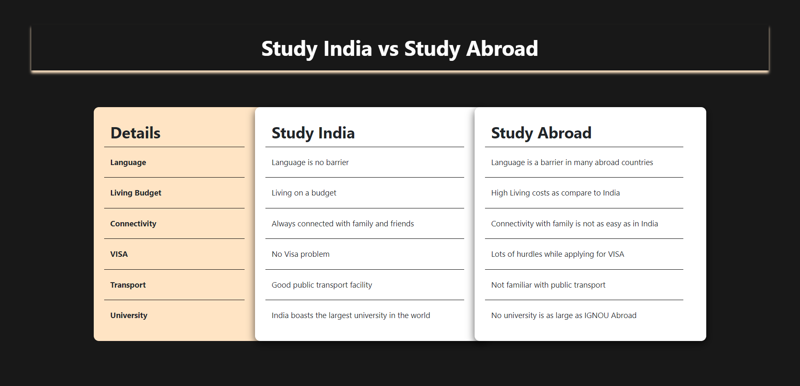

*Important*

Color Code:

background-color: rgb(24, 24, 24); —------------------Screen Background Color

box-shadow: 0 5px 5px bisque; —------------------- Heading Box Shadow

background-color: bisque; —---------------------- Card (Details)

box-shadow: rgba(0, 0, 0, 0.653) 0px 5px 15px; —----------Card Box Shadow

*Important*

**Folder Structure of the Project** **:**

* Home
  + Components — Folder
  + Image — Folder
  + Home.jsx — File
  + Style — Folder
    - Style.css — File

*Important*

**Requirements or contents of the page:**

1. The website should be responsive on all the devices like Desktop, Ipad, and mobile.
2. Css should be your own.
3. You can use Bootstrap5 and MUI.
4. The code should be clean.
5. Add a comment to elaborate on your code.